May 24, 2024

Endorsement of Debbie Waldrep

As a new law firm owner, I just moved into my very first office. I knew I had to get commercial insurance to protect my business from the worst of events. I was concerned about fire, theft, liability claims, and just about everything else under the sun – you name it, I was worrying about it!

Meeting Debbie was a blessing. As an independent insurance adjuster, she was exactly the type of professional I needed to meet at exactly the right time. Even more importantly, she’s the kind of person I needed to work with. Not only is Debbie extremely knowledgeable and experienced in her field, but she’s a caring human being who wanted to put my racing mind at ease.

Debbie knew exactly what coverages I needed, and she knew which insurance companies tend to provide the best service and rates to small law firms just like mine. When she brought me the best available quote (which was lower than I expected) from the best available company, I still had questions about the declarations page and wondered what would happen with my coverage should certain unfortunate events arise. Even though Debbie was sure of the answers, she still reached out to the insurer’s underwriter to triple-check and make me feel better within minutes.

As an attorney and a new business owner, I always have a lot on my mind. Thanks to Debbie, whether my business’s insurance covers me from every angle is no longer one of those things. I wholeheartedly recommend Debbie to anyone who needs insurance to protect them from suffering financially when unforeseeable events happen. I’ll be calling her again when it’s time to renew my auto insurance!

Very truly yours,
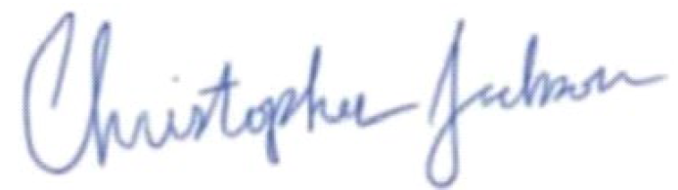
________________________________
Christopher Jackson
Principal Attorney
Jackson Injury Law

