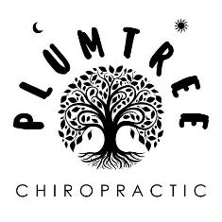

From:
Dr. Halina Krupa
Plum Tree Chiropractic
1875 Old Alabama Rd. Suite 715
Roswell, GA 30076
470 844 9018

To:
Jai Lee Galanti
Organic Movement Studio
295 W Crossville Rd.
Roswell GA 30075

I’ve been into the holistic health movement for over 30 years so I’ve pretty much done everything from massage, acupuncture, Reiki, chiropractic, but I treated myself to something completely new with Jai Lee at her studio—a sound healing session.
I wanted relief from some PTSD symptoms of overwhelm and lack of sleep. What I appreciated the most is Jai Lee’s grounded energy and directive which helped me self-regulate, relax into the session and allow my body to process in its own unique way. I knew I was in the hands of a skilled healer when she simply held space for me in silence and allowed the work to do the work. I left feeling lighter and calmer.
I highly recommend her beautiful studio and her services.

Dr. Halina Krupa

