

Amanda Carroll Jonathan Ongtingco
2353 Owens Valley Run NW 4198 Alaina Circle
Kennesaw, GA 30152 Austell, GA 30106

Amanda,

A year ago I could not lift heavy objects or go up steps without taking a short nap afterwards. You have worked with me for about 6 months and the changes have been very pleasing. Guiding me through the workout process helped get me back into moving my body while avoiding injury. I can lift very heavy items once again. My Nephews once again fear wrestling with me. I am able to take my daughter rock climbing and participate without fear of becoming too tired or hurting myself in the process. You have a great feel for pushing me while recognizing when I have pushed too far and need to reel it in. I look forward to continued growth under your expert guidance, and I mean that literally in the biceps.

Thank you,
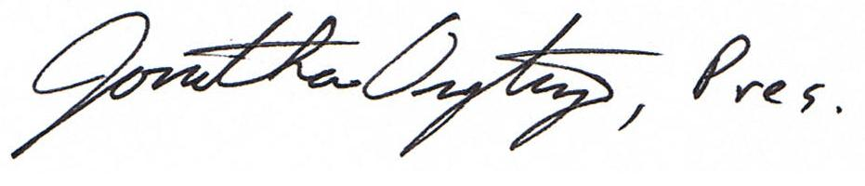
Jonathan Ongtingco

