
Annie
Your SuperSonicPitBull REALTOR®
770-374-7197 – cell 770-632-1112 – office
AnnieDB@KW.com

Domonique Downing
Big Frog of Fayetteville
domoniqued@bigfrog.com
919-619-6179

Domonique-

This is a big heartfelt “thank you” for the great printing work you did on the Independence Day canvas bags I needed to give as pop-by gifts for my favored clients and vendors. So many have complimented on the quality of the bag and the printing,

You were instrumental in helping me choose the correct bag at the right price, as well as patient, while I determined the final number to order and finished up the design. More importantly, you delivered them on time—understanding that It was going to take more than a couple days for me to personally deliver them.

When my son saw them, he asked me why I didn’t have his dog on the bag too. So I asked if you could print a few bags with Buck on the other side. You delivered them by lunchtime, on a day I later found out you were supposed to be closed, so I could surprise everyone in my family with the double-sided bags before they left for home.

This kind of above and beyond service, in addition to the excellent quality, is what builds relationship and makes it easy to recommend you and your company for any type of promotional product.
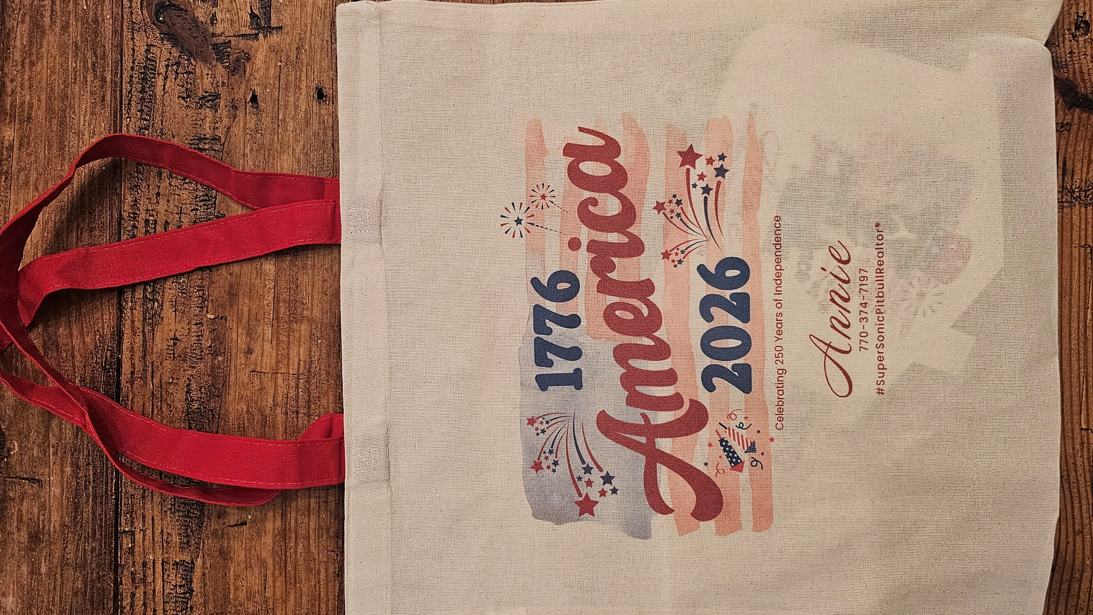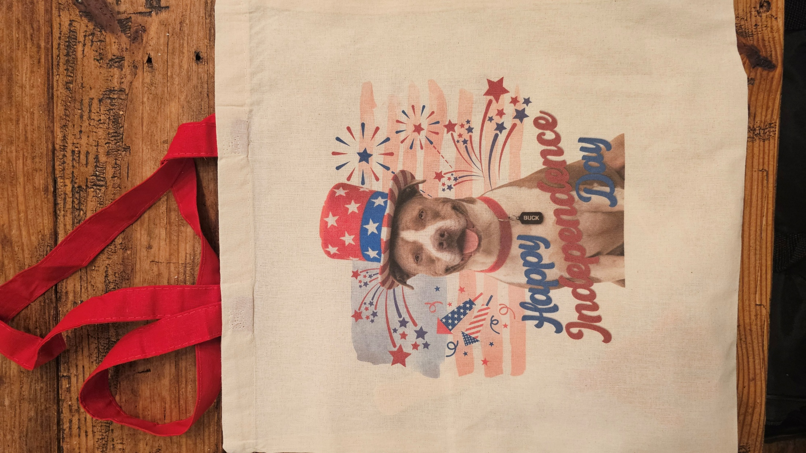
With Gratitude,

Annie DeRose-Broeckert
Wife to Ken, Mom to Daniel, Gabriel & Michael
SuperSonicPitBullREALTOR®

