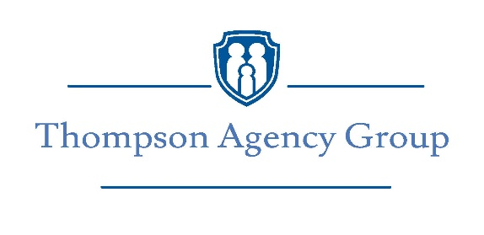
I met Ray Evans with Element Funding in 2018 and in every sense of the word he has proven to be a ‘True Professional’ in the Mortgage business. His passion for helping clients is noticeable from any initial connection with him. He has referred many of his clients to us and he has been able to assist many of our existing clients and every time we hear that they are funding their home or refinance working with Ray, we are confident that they will experience his professionalism and knowledge in getting their deal done.
Here are just a couple of examples of our client’s remarks about working with Ray:
Ray Evans, Element Funding, helped me with financing when I purchased my home. A process that can be confusing and cumbersome went smoothly with Ray and his staff in charge from beginning to end. When I refinanced my home a couple of years later, I did not hesitate to contact Ray Evans and I was not disappointed. In both cases, they found the best interest rate and terms that fit my budget. Communication means everything in this process and I was kept informed every step of the way. I am happy to recommend Ray Evans, Element Funding, to everyone who is purchasing or refinancing a home.
-------- C. Broderick
Ray helped us with our Home Loan and he made the entire process feel seamless and easy and handled any concerns like it was not a problem. We really appreciated the rate we were able to get and how he managed the application and approval for us. His attention to detail was better than we could have realized and we will certainly recommend him to our friends and family.
-------- W. Lawrence
It is with complete confidence that I recommend Ray Evans, Element Funding, for any and all your mortgage and lending needs.
Sincerely,

John Thompson
President/Owner
Thompson Agencies Group, LLC / Allstate
300 Bullsboro Dr. #D Newnan, GA 30263
770-757-1375

