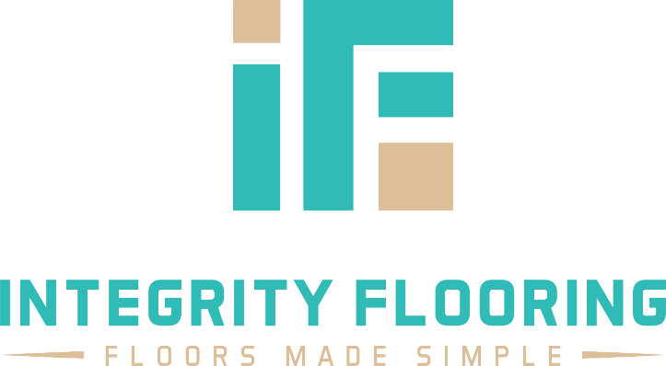
To whom this may concern,

Recently Jacque conducted a free skin consultation with my mom, Ann. She made sure to schedule a call ahead of time to ask Ann some preliminary questions to ensure she was prepared for their appointment.

When they met, she asked my mom what her major concerns were and truly focused on those concerns. She didn’t push any products that did not directly address my mom’s needs. Jacque was kind, understanding, and helpful. Three characteristics my mom really appreciated.

My mom left the consultation, looking great, feeling great and raving about Jacque. I highly recommend Jacque to anyone wanting guidance on how to better take care of their skin without worrying about being sold too.

Thank you, Jacque!

Sincerely,
Jason Wettlin, Owner
Integrity Flooring of Georgia

