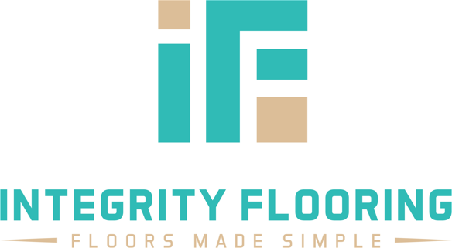

To whom this may concern,

I recently had massive white oak tree that was struck by lightning, fall on my property. I asked 3 tree companies give me quotes. What I found through this experience was that Georgia Tree Masters was the most knowledgeable, helpful, and professional of the companies in consideration. I chose them not only for these reasons but because they were also the only insured company and most importantly, their prices were just as competitive as the quotes from the other companies. On top of that, David, the owner is a certified arborist, something I know both of the other two companies did not have.

Once I was scheduled, David and his team had great communication. My need was fairly urgent and to my great surprise, they were able to work me in a day early. They addressed the job as we had discussed, and they did a fantastic job. I highly recommend Georgia Tree Masters for all of your tree removal and pruning needs.

Sincerely,

Jason Wettlin
Owner, Integrity Flooring of Georgia

