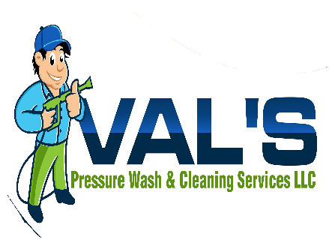

Dear Russell Davis,
Thank you for your much appreciated help with Val’s Pressure Wash & Cleaning Services. Russell Davis who is the business owner of Mermaid Hunter Photgraphy and Drone services support has been invaluable. It was great working with you on the pressure washing project. The before and after pictures turned out great. Val’s truly appreciate your work and I'm very grateful.
Sincerely,
Etheline Valmond

